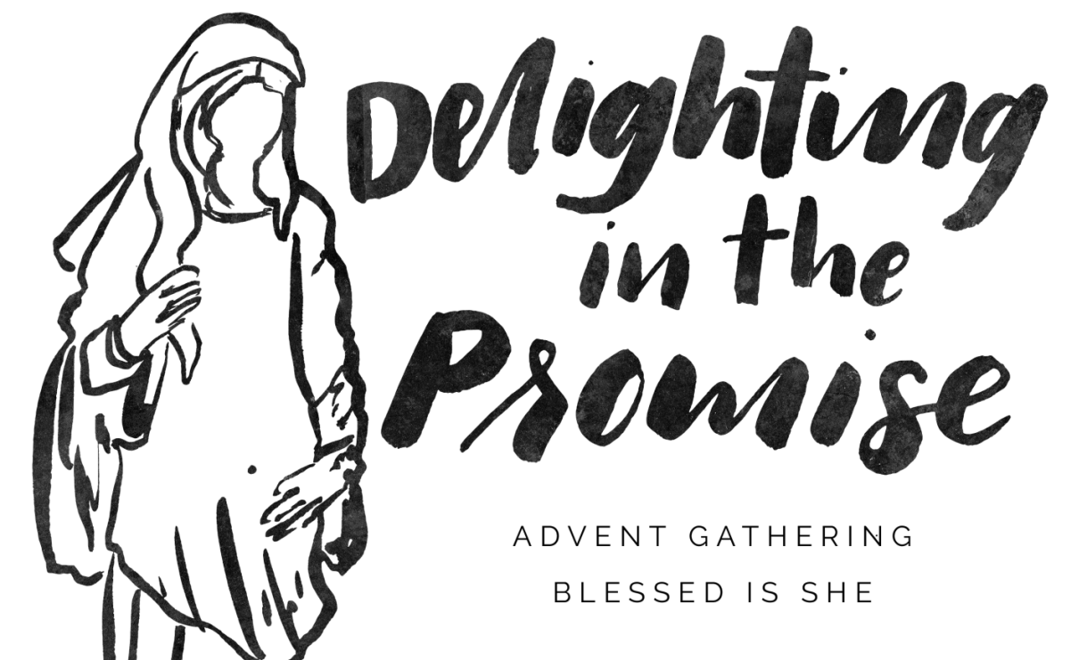

**RSVP by November 20th**

Please join the Whispering Winds Women’s Auxiliary on December 9th @ Our Mother of Confidence for an Advent mini retreat.

6:30 p.m. - Social in Serra Hall 7:00 - 8:30p.m. - Retreat

Our Mother of Confidence Church 3131 Governor Dr. San Diego, CA 92122

We will gather together, watch a virtual talk, and discuss reflection questions afterward — all helping us prepare in the season of Advent for our Lord to fulfill the Promise at Christmas. To end the evening in style we’ll sing a few Christmas carols! Please bring a mother, sister, friend!

**Please register & pay on-line @:** [**www.blessedisshe.net**](http://www.blessedisshe.net)

**Click on: ‘Shop #BIS Advent’, ‘Advent Gathering RSVP’**

**Find our City: San Diego Dec. 9 @ 6:30**

**‘Add to cart’ & Check out @ purple bar. $20.00+shipping**

Questions? Contact Carolyn Kalb: [kalbcarolyn@gmail.com](mailto:kalbcarolyn@gmail.com), 619-318-6493